FIELD REPORT
Introduction
- Place: Ajaga HC III
- Location: Oyam district
- Date of visit:
1. General observations
Most of the items were in the store.
Special notes
Some of the names of the items were not known during the verification process.
All assets are not engraved

The table below illustrates some physical status of the verified assets with photographic evidence.
Table XXX: Physical verification photos
SAMPLE OF ITEMS IN STORE | 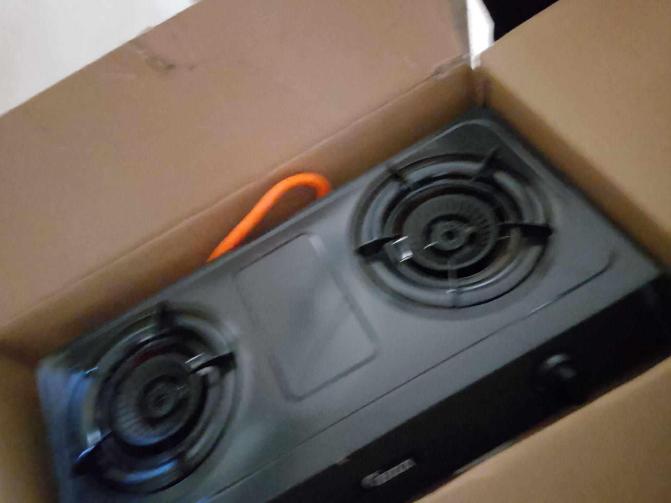
SAMPLE OF ITEMS IN STORE | 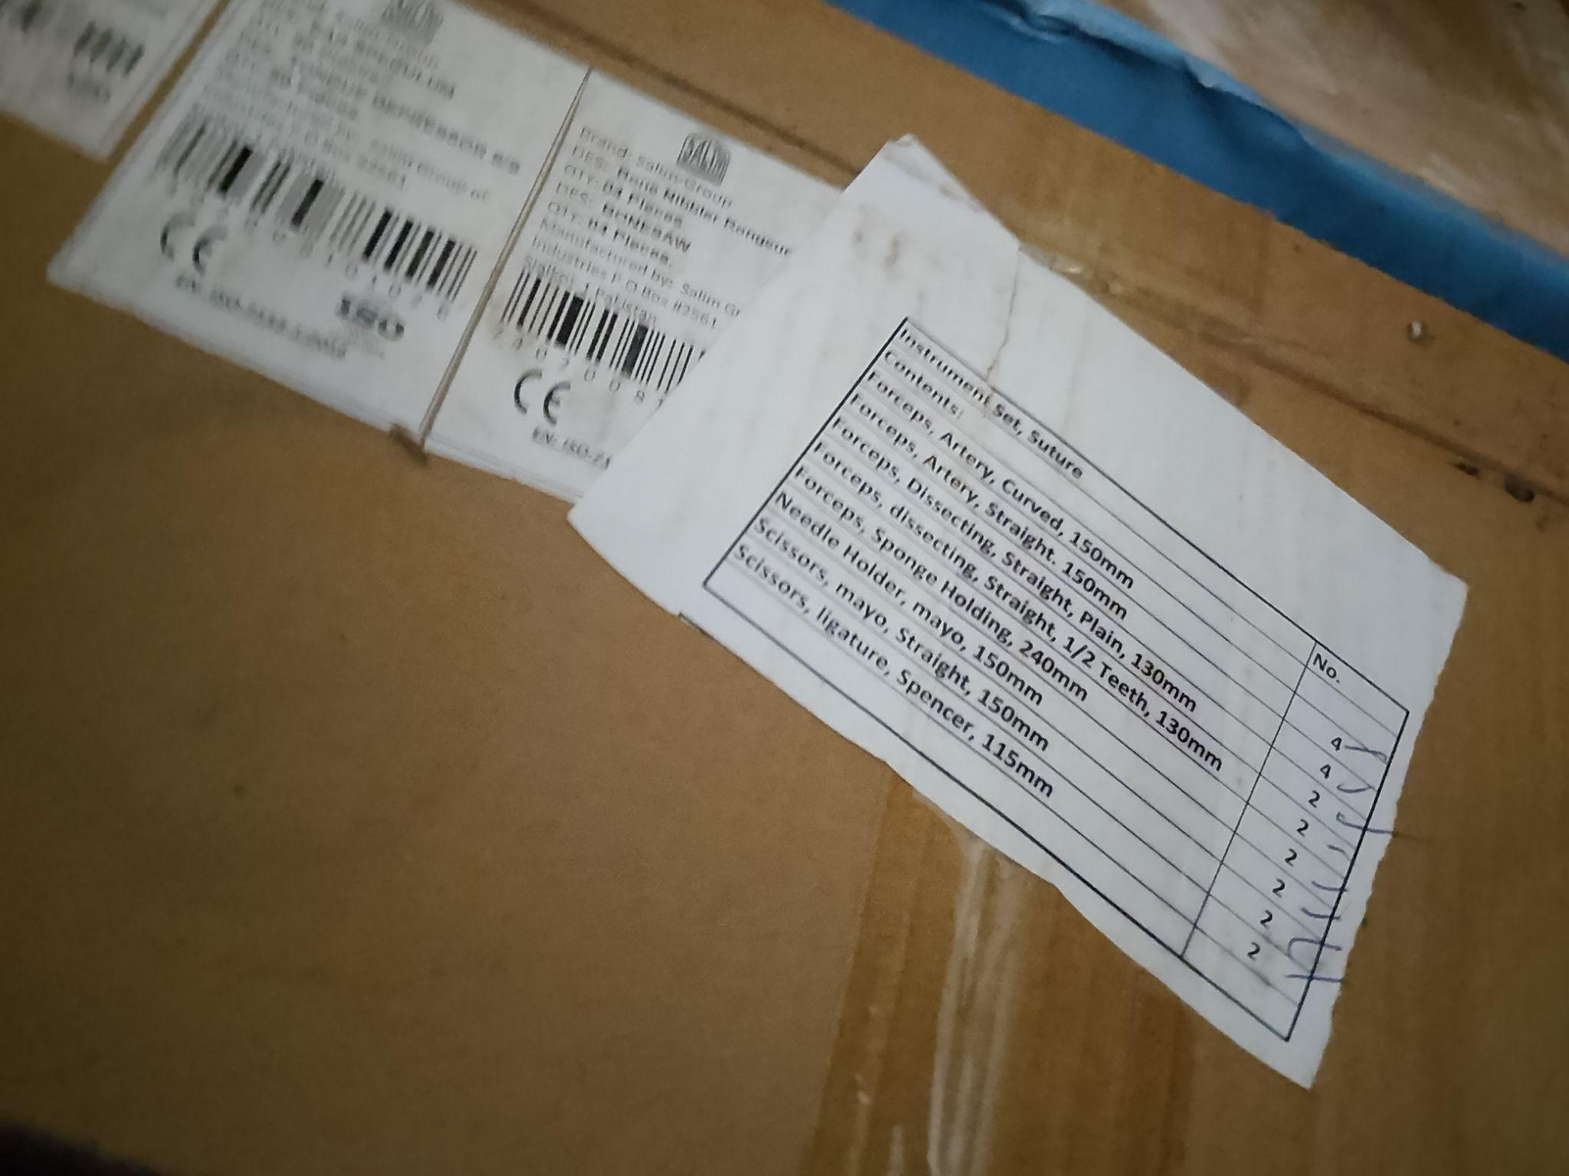
SAMPLE OF ASSETS IN STORE | 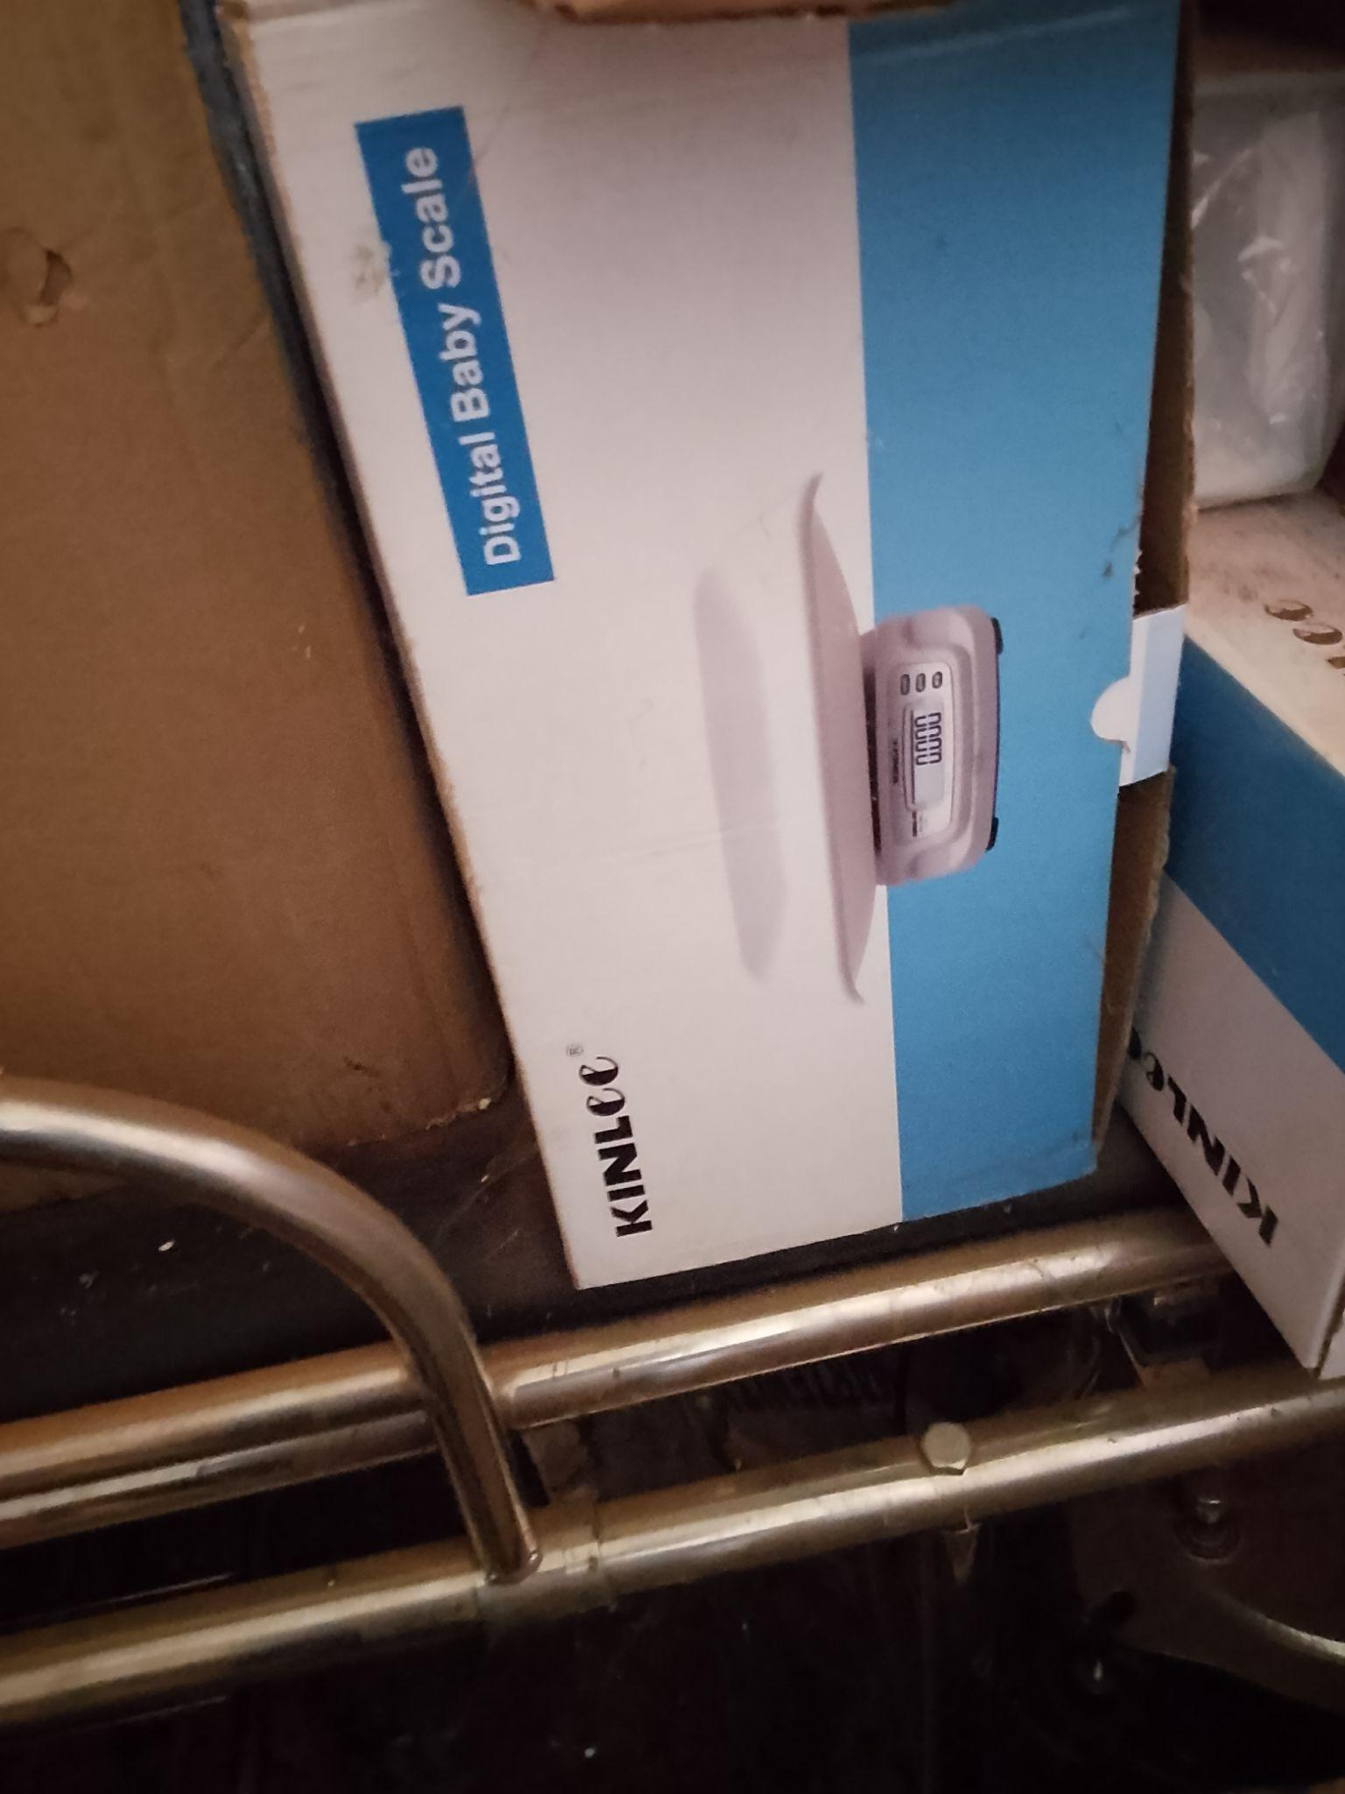
SAMPLE OF ASSETS IN STORE | 